**Florida International University**

**COP 4710 – Database Management**

**Final Project**

**Value: 100 points (30% weight of the grading of the course)**

**Due Date: December 4th , 2022 11:59 pm**

Instructor: Lenis Hernandez

In this project, **you are required** to design and implement a database for a real miniworld environment based on the given database requirements. The deliverable for this assignment must include:

1. The ER diagram, relational schemas and the corresponding relation instance for the database.
2. The SQL scripts for the database creation and data population.
3. Your deliverable for this assignment should include the SQL scripts for each query question and corresponding answer (you can include the query results as plain text files in a readable format).

**You are given** a set of requirements for a hospital system database. Based on the set of requirements for the hospital system database, you are asked to do the following:

1. **Design** the conceptual schema for the hospital system database by using an ER diagram in UML format. Your conceptual design of the database should include the following but not limit to (20 points):  
a. Entities

b. Relationships

c. Keys

**ER DIAGRAM**

2. **Transform the ER schema** of the database you get from step 1 into the corresponding relational database schema. Example Fig. 5.8 page 172 of the textbook. (10 points)

1. Specify all the key attributes of relations and any referential integrity constraints.
2. Specify the data item format for each attribute in each relation schema.
3. Specify all the functional dependencies you could infer from the requirements.

**Relational Schema**

**3. Normalize the** relation schema in the database design that you get from step 4 into either 3NF or BCNF if it is necessary.

**4. Implement the relational database** you get in step 5 via PostgreSQL; this includes creating the database, creating the corresponding relation schemas, data preparation, and loading data into the database. (30 points)

**POPULATING THE DATABASE:**

CREATE TABLE JOB

(

TypeCode INT NOT NULL,

Description VARCHAR(15) NOT NULL,

PRIMARY KEY (TypeCode)

);

CREATE TABLE EMPLOYEES

(

EmpNumber INT NOT NULL,

SSN CHAR(16) NOT NULL,

Fname VARCHAR(15) NOT NULL,

LName VARCHAR(20) NOT NULL,

DOB DATE NOT NULL,

Gender CHAR(1) NOT NULL,

PhoneNum VARCHAR(14) NOT NULL,

Street VARCHAR(30) NOT NULL,

HouseNum INT NOT NULL,

City VARCHAR(25) NOT NULL,

State VARCHAR(25) NOT NULL,

Zipcode INT NOT NULL,

JobType INT NOT NULL **DEFAULT** 0,

Salary INT NOT NULL,

**CONSTRAINT** EMPPK

PRIMARY KEY (EmpNumber),

**CONSTRAINT** EMP_FK

**FOREIGN KEY** (JobType) **REFERENCES** JOB(TypeCode)

**ON DELETE** SET **DEFAULT** ON UPDATE CASCADE,

UNIQUE (SSN)

);

CREATE TABLE TREATMENT

(

Ilness_Type VARCHAR(30) NOT NULL,

PRIMARY KEY (Ilness_Type)

);

CREATE TABLE SPEC_DOCTOR

(

SpecID INT NOT NULL,

Description VARCHAR(20) NOT NULL,

PRIMARY KEY (SpecID)

);

CREATE TABLE DOCTOR

(

EmpNumber INT NOT NULL,

License VARCHAR(20) NOT NULL,

SpecID INT **DEFAULT** -1,

PRIMARY KEY (EmpNumber),

**CONSTRAINT** DOCFK

**FOREIGN KEY** (EmpNumber) **REFERENCES** EMPLOYEES(EmpNumber)

**ON DELETE CASCADE** ON UPDATE CASCADE,

**CONSTRAINT** DOCTOR_SPECFK

**FOREIGN KEY** (SpecID) **REFERENCES** SPEC_DOCTOR(SpecID)

**ON DELETE** SET **DEFAULT** ON UPDATE CASCADE,

UNIQUE (License)

);

CREATE TABLE NURSE

(

Registration VARCHAR(40) NOT NULL,

EmpNumber INT NOT NULL,

PRIMARY KEY (EmpNumber),

**CONSTRAINT** NURSPK

**FOREIGN KEY** (EmpNumber) **REFERENCES** EMPLOYEES(EmpNumber)

**ON DELETE CASCADE** ON UPDATE CASCADE,

UNIQUE (Registration)

);

CREATE TABLE ROOM_TYPE

(

Code INT NOT NULL,

Description VARCHAR(20) NOT NULL,

PRIMARY KEY (Code)

);

CREATE TABLE ROOM

(

PRoom VARCHAR(6) NOT NULL,

Nurse INT NOT NULL **DEFAULT** 222222,

TypeCode INT **DEFAULT** 0,

PRIMARY KEY (PRoom),

**CONSTRAINT** PATFROOM

**FOREIGN KEY** (Nurse) **REFERENCES** NURSE(EmpNumber)

**ON DELETE** SET **DEFAULT** ON UPDATE CASCADE,

**CONSTRAINT** ROOM_TYPEFK

**FOREIGN KEY** (TypeCode) **REFERENCES** ROOM_TYPE(Code)

**ON DELETE** SET **DEFAULT** ON UPDATE CASCADE

);

CREATE TABLE RECEPCIONIST

(

TypingSpeed INT NOT NULL,

EmpNumber INT NOT NULL,

PRIMARY KEY (EmpNumber),

**CONSTRAINT** RECEPTSK

**FOREIGN KEY** (EmpNumber) **REFERENCES** EMPLOYEES(EmpNumber)

**ON DELETE CASCADE** ON UPDATE CASCADE

);

CREATE TABLE MEDICINE

(

Code VARCHAR(10) NOT NULL,

MedInfo VARCHAR(60) NOT NULL,

MedPrice DECIMAL(5,2) NOT NULL,

MedQuantity INT NOT NULL,

PRIMARY KEY (Code)

);

CREATE TABLE CONTAINS

(

Ilness_Type VARCHAR(30) NOT NULL,

Code VARCHAR(10) NOT NULL,

PRIMARY KEY (Ilness_Type,Code),

**CONSTRAINT** CONTFKMED

**FOREIGN KEY** (Ilness_Type) **REFERENCES** TREATMENT(Ilness_Type)

**ON DELETE CASCADE** ON UPDATE CASCADE,

**FOREIGN KEY** (Code) **REFERENCES** MEDICINE(Code)

);

CREATE TABLE PATIENT

(

PatientId INT NOT NULL,

SSN CHAR(16) NOT NULL,

Fname VARCHAR(15) NOT NULL,

LName VARCHAR(20) NOT NULL,

DOB DATE NOT NULL,

Gender CHAR(1) NOT NULL,

Age INT NOT NULL,

PhoneNum VARCHAR(14) NOT NULL,

Street VARCHAR(30) NOT NULL,

HouseNum INT NOT NULL,

City VARCHAR(25) NOT NULL,

State VARCHAR(25) NOT NULL,

Zipcode INT NOT NULL,

ERVISIT **BOOLEAN** NOT NULL,

DateAdmitted DATE NOT NULL,

AdmtMonth VARCHAR(20) NOT NULL,

AdmtYear INT NOT NULL,

DateDischarg DATE,

Doctor INT NOT NULL **DEFAULT** 111111,

PRoom VARCHAR(6) NOT NULL **DEFAULT** '0000',

**CONSTRAINT** PATPK

PRIMARY KEY (PatientId),

**CONSTRAINT** PATFKDOC

**FOREIGN KEY** (Doctor) **REFERENCES** DOCTOR(EmpNumber)

**ON DELETE** SET **DEFAULT** ON UPDATE CASCADE,

**CONSTRAINT** PATFROOM

**FOREIGN KEY** (PRoom) **REFERENCES** ROOM(PRoom)

**ON DELETE** SET **DEFAULT** ON UPDATE CASCADE,

UNIQUE (SSN)

);

CREATE TABLE RECORD

(

RecordNum INT NOT NULL,

ApptDate DATE NOT NULL,

PTObsert VARCHAR(30) NOT NULL,

PatientId INT NOT NULL,

ReceptWorked INT NOT NULL **DEFAULT** 333333,

PRIMARY KEY (RecordNum, PatientId),

**CONSTRAINT** RECFKPAT

**FOREIGN KEY** (PatientId) **REFERENCES** PATIENT(PatientId)

**ON DELETE CASCADE** ON UPDATE CASCADE,

**CONSTRAINT** RECFKRECEP

**FOREIGN KEY** (ReceptWorked) **REFERENCES** RECEPCIONIST(EmpNumber)

**ON DELETE** SET **DEFAULT** ON UPDATE CASCADE

);

CREATE TABLE RECEIVES

(

PatientId INT NOT NULL,

Ilness_Type VARCHAR(30) NOT NULL,

PRIMARY KEY (PatientId,Ilness_Type),

**CONSTRAINT** RECEFKPAT

**FOREIGN KEY** (PatientId) **REFERENCES** PATIENT(PatientId)

**ON DELETE CASCADE** ON UPDATE CASCADE,

**FOREIGN KEY** (Ilness_Type) **REFERENCES** TREATMENT (Ilness_Type)

);

**INSERTING DATA INTO TABLES**

INSERT INTO JOB

VALUES

(1, 'Doctor'),

(2, 'Nurse'),

(3, 'Receptionist');

INSERT INTO employees

values

(67, '605-78-7291', 'Sofia', 'Rodriguez', '8/5/1988', 'F', '989-758-0504', 'Killdeer', '12', 'Saginaw', 'Michigan', '48604', 3, '79484'),

(41, '632-02-6566', 'Margorie', 'Smith', '7/10/1981', 'F', '202-244-0223', 'Esch', '14', 'Washington', 'District of Columbia', '20205', 2,'168131'),

(11, '656-67-1690', 'Emilsa', 'Ruiz', '12/3/1989', 'F', '210-215-9550', 'Lerdahl', '41', 'San Antonio', 'Texas', '78210', 2, '191024'),

(61, '249-77-4704', 'Joseph', 'Kennedy', '11/24/1999', 'M', '310-319-4890', 'Doe Crossing', '33', 'Santa Monica', 'California', '90410', 3,'67437'),

(128, '231-67-7097', 'Mary', 'Bryant', '9/12/1960', 'F', '816-886-2865', 'Fair Oaks', '12', 'Kansas City', 'Missouri', '64130', 3,'47196'),

(101, '693-92-5188', 'Michael', 'Houston', '5/9/1990', 'M', '405-982-5729', 'Maple', '6', 'Oklahoma City', 'Oklahoma', '73173', 2,'153244'),

(87, '825-92-5850', 'Linda', 'Santiago', '6/27/1982', 'F', '210-715-0432', 'Northridge', '7', 'San Antonio', 'Texas', '78230', 3,'58583'),

(93, '190-40-7849', 'Luis', 'Rodriguez', '4/12/1961', 'M', '763-175-2515', 'Columbus', '52', 'Monticello', 'Minnesota', '55585', 2,'141215'),

(25, '613-04-6109', 'Mario', 'Szen', '9/28/1969', 'M', '713-663-7068', 'Dennis', '12', 'Houston', 'Texas', '77271', 2,'184031'),

(102, '265-20-4653', 'Dandra', 'Jackson', '2/8/1989', 'F', '717-698-2908', 'Thierer', '3', 'Harrisburg', 'Pennsylvania', '17110', 2,'98065'),

(121, '585-14-2191', 'Whitney', 'Spears', '8/4/1977', 'F', '540-619-7336', 'Rusk', '9', 'Roanoke', 'Virginia', '24048', 1,'205863'),

(66, '493-11-8673', 'Jose Luis', 'Figueroa', '10/29/1960', 'M', '915-717-7982', 'Mccormick', '10', 'El Paso', 'Texas', '79977', 2,'158820'),

(54, '232-27-5381', 'Joselina', 'Linstead', '10/3/1974', 'F', '801-379-6338', 'Westridge', '14', 'Salt Lake City', 'Utah', '84140', 2,'187783'),

(34, '256-40-3219', 'Darlleen', 'Powells', '7/8/1968', 'F', '702-653-9627', 'Novick', '18', 'Las Vegas', 'Nevada', '89130', 2,'147671'),

(58, '532-54-1967', 'Fernando', 'Adams', '2/20/1992', 'M', '414-360-2584', 'Scott', '35', 'Milwaukee', 'Wisconsin', '53285', 2, '100716'),

(44, '276-94-9507', 'Alexander', 'Ruiz', '1/7/1976', 'M', '303-617-6109', 'Clemons', '13', 'Englewood', 'Colorado', '80150', 1,'204770'),

(84, '313-69-2237', 'Harper', 'Mills', '8/14/1980', 'M', '361-986-1853', 'Doe Crossing', '15', 'Corpus Christi', 'Texas', '78410', 1,'213309'),

(103, '414-87-6565', 'Tyler', 'Cudd', '7/11/1976', 'M', '515-245-2883', 'Vernon', '4', 'Des Moines', 'Iowa', '50330', 2,'87361'),

(70, '513-95-9272', 'Devin', 'Tebbet', '9/13/1989', 'M', '504-539-6321', 'Debra', '2', 'New Orleans', 'Louisiana', '70174', 3,'49600'),

(15, '157-21-6898', 'Leticia', 'Elsmore', '8/13/1969', 'F', '786-916-1764', 'Stoughton', '5', 'Homestead', 'Florida', '33034', 1,'244281'),

(117, '523-33-2427', 'Patrizio', 'Rodriguez', '9/27/1974', 'M', '520-756-1859', 'Tennessee', '7', 'Tucson', 'Arizona', '85743', 2,'89047'),

(92, '899-65-6555', 'Omar', 'Channing', '11/17/1994', 'M', '352-288-2918', 'Browning', '8', 'Ocala', 'Florida', '34474', 3,'64942'),

(69, '491-52-1827', 'Nerdiz', 'Lazcano', '11/21/1980', 'M', '260-515-3182', 'Pleasure', '4', 'Fort Wayne', 'Indiana', '46825', 3,'70868'),

(24, '795-79-5598', 'Maria Luisa', 'Branchett', '3/15/1990', 'F', '972-405-0425', 'Blue Bill Park', '9', 'Dallas', 'Texas', '75246', 1,'208368'),

(1, '848-19-4176', 'Cristopher', 'Filyukov', '4/8/1961', 'M', '615-166-3886', 'Butterfield', '3', 'Nashville', 'Tennessee', '37240', 2,'84521'),

(62, '869-70-5042', 'Karina', 'Spaven', '12/12/1993', 'F', '202-452-3796', 'Lake View', '2', 'Washington', 'District of Columbia', '20088', 2,'168420'),

(82, '820-99-4278', 'Alain', 'Overil', '6/26/1996', 'M', '281-137-8196', 'Gulseth', '7', 'Houston', 'Texas', '77055', 2,'114683'),

(52, '511-37-2883', 'Perla', 'Marrison', '4/11/1994', 'F', '614-476-3695', 'Bartillon', '9', 'Columbus', 'Ohio', '43240',2, '95956'),

(118, '654-07-3780', 'Miguel', 'Ruiz', '11/12/1965', 'M', '952-356-0980', 'Evergreen', '12', 'Young America', 'Minnesota', '55564', 2,'106952'),

(150, '365-47-7910', 'Yehan', 'Janik', '3/30/1973', 'M', '405-672-3653', 'Hovde', '13', 'Oklahoma City', 'Oklahoma', '73104', 3,'57154'),

(116, '529-97-6182', 'Lydon', 'Mackriell', '8/23/1996', 'M', '808-386-4425', 'Dapin', '15', 'Honolulu', 'Hawaii', '96805', 2,'199603'),

(17, '696-15-2652', 'Aylmer', 'Face', '8/2/1966', 'M', '786-503-9109', 'Dayton', '5', 'Miami', 'Florida', '33245',1, '207723'),

(37, '154-26-9269', 'Hendrik', 'MacTimpany', '3/31/1980', 'M', '225-427-2766', 'Crownhardt', '8', 'Baton Rouge', 'Louisiana', '70820',2, '182761'),

(75, '600-53-4630', 'Peirce', 'Heynel', '4/24/1973', 'M', '330-425-4113', 'Parkside', '9', 'Youngstown', 'Ohio', '44511', 2,'177383'),

(99, '156-65-7704', 'Jeremias', 'Mota', '10/25/1987', 'M', '214-137-9394', 'Lakewood', '14', 'Dallas', 'Texas', '75265', 3,'69079'),

(115, '692-89-8914', 'Bond', 'Fisk', '1/1/1990', 'M', '704-492-3459', 'Lerdahl', '7', 'Charlotte', 'North Carolina', '28215', 1,'211937'),

(28, '899-33-6572', 'Westbrooke', 'Windybank', '1/16/1995', 'M', '786-367-7813', 'Grayhawk', '9', 'Miami', 'Florida', '33245',1, '213692'),

(57, '768-29-8211', 'Vinny', 'Hammersley', '6/29/1981', 'M', '425-351-2649', 'Derek', '6', 'Seattle', 'Washington', '98115',2, '174198'),

(126, '589-32-3143', 'Samuel', 'Charpin', '5/18/1982', 'M', '903-119-9118', 'David', '9', 'Texarkana', 'Texas', '75507', 1,'246177'),

(26, '677-69-8124', 'Penn', 'O'' Borne', '9/19/1989', 'M', '309-913-0908', 'Knutson', '22', 'Carol Stream', 'Illinois', '60351', 2,'102292'),

(42, '573-62-2099', 'Holden', 'Ladd', '1/17/1975', 'M', '702-146-4796', 'Aberg', '56', 'Las Vegas', 'Nevada', '89125', 2,'165106'),

(33, '461-01-4403', 'Kay', 'Woofendell', '12/21/1996', 'F', '331-417-4308', 'Packers', '5', 'Aurora', 'Illinois', '60505', 2,'173750'),

(18, '788-60-7086', 'Bron', 'McIndrew', '1/23/1978', 'M', '304-651-1667', 'Johnson', '7', 'Charleston', 'West Virginia', '25305', 1,'230396'),

(14, '573-31-5783', 'Bradan', 'Tombs', '8/17/1985', 'M', '510-794-4113', 'Blue Bill Park', '23', 'Oakland', 'California', '94605', 2,'118777'),

(60, '133-54-0362', 'Herb', 'Ohanessian', '1/29/1978', 'M', '410-133-6972', 'Delaware', '31', 'Ridgely', 'Maryland', '21684', 2,'82372'),

(46, '347-75-7143', 'Hamish', 'Gerwood', '10/7/1990', 'M', '214-398-8994', 'Ruskin', '64', 'Mesquite', 'Texas', '75185', 1,'247801'),

(88, '392-84-3556', 'Gage', 'Rabidge', '1/14/1985', 'M', '716-293-1310', 'Anderson', '34', 'Buffalo', 'New York', '14225', 2,'112478'),

(47, '376-77-6562', 'Laurens', 'Bartalini', '11/8/1987', 'M', '321-874-8309', 'Del Sol', '45', 'Orlando', 'Florida', '32835',2, '156605'),

(120, '751-65-5777', 'Phelia', 'Malatalant', '1/6/1988', 'F', '651-423-8234', 'Lake View', '32', 'Minneapolis', 'Minnesota', '55441',2, '119959'),

(90, '254-13-7176', 'Jeffy', 'Kristoffersson', '2/2/1996', 'M', '412-366-3447', 'Crownhardt', '34', 'Pittsburgh', 'Pennsylvania', '15240', 2,'168903'),

(9, '177-62-6172', 'Zane', 'Costard', '3/6/1961', 'M', '508-458-2216', 'Anthes', '35', 'Brockton', 'Massachusetts', '02305', 3,'45468'),

(10, '337-03-9344', 'Adan', 'Sandars', '11/22/1985', 'M', '763-971-4982', 'Birchwood', '36', 'Minneapolis', 'Minnesota', '55448', 2,'170487'),

(50, '749-50-1628', 'Amanda', 'Angus', '11/18/1999', 'F', '602-292-5682', 'New Castle', '12', 'Phoenix', 'Arizona', '85083', 2,'124346'),

(71, '809-77-8802', 'Jamil', 'Caltun', '1/11/1976', 'M', '602-986-6078', 'West', '16', 'Phoenix', 'Arizona', '85099', 2,'142672'),

(32, '225-96-0052', 'Antonella', 'Barnett', '2/25/1974', 'F', '562-209-2823', 'Miller', '16', 'Los Angeles', 'California', '90020', 2,'81604'),

(51, '462-27-3007', 'Christianne', 'Upstone', '11/3/1973', 'F', '701-595-5117', 'Ohio', '16', 'Grand Forks', 'North Dakota', '58207', 3,'58211'),

(49, '593-43-1303', 'Garreth', 'Casey', '5/11/1973', 'M', '304-618-9217', 'Moland', '15', 'Charleston', 'West Virginia', '25356', 3,'69675'),

(53, '873-29-2808', 'Reinaldo', 'Spreull', '8/23/1980', 'M', '408-285-5718', 'International', '14', 'San Jose', 'California', '95133',1, '227439'),

(98, '520-51-3017', 'Jorge', 'Draco', '4/17/1996', 'M', '818-598-7076', 'Sunbrook', '15', 'Los Angeles', 'California', '90025', 2,'161457'),

(78, '238-66-1246', 'Kane', 'Palek', '3/14/1981', 'M', '267-203-0302', '1st', '16', 'Philadelphia', 'Pennsylvania', '19115', 2,'106597'),

(200, '690-98-2120', 'Fidel', 'Ortells', '4/22/2000', 'M', '952-467-2351', 'Holmberg', '2', 'Minneapolis', 'Minnesota', '55446', 1,'219355'),

(197, '118-15-9384', 'Russell', 'Kunc', '2/25/1974', 'M', '805-397-7083', 'Chinook', '5', 'Ventura', 'California', '93005', 1,'249088'),

(190, '496-23-4181', 'Ashlean', 'McReedy', '7/21/1976', 'F', '717-182-6532', 'Fuller', '12', 'Harrisburg', 'Pennsylvania', '17126', 1,'215980'),

(183, '196-40-4678', 'Rem', 'Rosin', '5/17/1999', 'M', '954-849-2514', 'Randy', '15', 'Fort Lauderdale', 'Florida', '33305', 1,'247722'),

(181, '821-37-1178', 'Leonel', 'Petran', '1/20/1977', 'M', '912-425-1050', 'Golf View', '14', 'Savannah', 'Georgia', '31410', 1,'227516'),

(179, '387-52-4427', 'Kevin', 'Good', '1/9/1970', 'M', '617-198-9820', 'Elgar', '8', 'Boston', 'Massachusetts', '02203', 1,'224254');

INSERT INTO SPEC_DOCTOR

values

(1, 'Internist'),

(2, 'Cardiologist'),

(3, 'Pulmonologist'),

(4, 'Nephrologist'),

(5, 'ENT'),

(6, 'Neurologist'),

(7, 'Neurologist'),

(8, 'Endocrinologist');

INSERT INTO doctor

VALUES

(44,'95-7902471',3),

(121,'74-3825470',4),

(179,'28-1389202',5),

(181,'69-9979955',6),

(183,'16-3923093',1),

(190,'85-0769444',2),

(197,'38-2414517',3),

(200,'24-5667292',7),

(53,'45-6662943',8),

(46,'97-4879521',1),

(18,'39-5543997',2),

(126,'76-8402086',4),

(28,'46-8279406',4),

(115,'48-4649865',5),

(17,'48-4318297',2),

(24,'71-7566546',2),

(15,'31-5315882',1),

(84,'30-4632543',6);

INSERT INTO nurse

VALUES

('1GYS3EEJ0DR340405',32),

('WDDGF4HB0ER671994',60),

('WBAUC9C58CV331613',1),

('WBA3F9C51EK278891',103),

('1GKLRKED4AJ505470',117),

('WAUDF98E28A679101',52),

('19UUA9F20BA104997',102),

('SCFAB02A57G393369',58),

('JN1AV7AP9FM138960',26),

('5J6TF1H5XEL742181',78),

('4T1BF1FK7CU674239',118),

('SAJWA4DC9EM095520',88),

('1G6DV1EP3E0145073',82),

('1GYUCKEF8AR322541',14),

('SAJWA2EK5EM553029',120),

('1GYUCDEF2AR565841',50),

('WAUDFAFLXDN986649',93),

('WBAYA6C53FD865733',71),

('WAUEG74FX6N629850',34),

('3GYFNEE35FS187047',101),

('WAUXU54B83N829883',47),

('JM3KE2BE0F0157767',66),

('3GYFNGEY5AS442618',98),

('WAUGL58E25A732518',42),

('1G6AD5SX7D0506515',41),

('2V4RW3D18AR003669',62),

('WP0AA2A81EK127661',90),

('1G4GC5GC4BF235774',10),

('5J8TB4H51GL259850',33),

('3D7TT2CT6AG117168',57),

('5UXXW5C55F0925463',75);

INSERT INTO RECEPCIONIST

VALUES

('70',9),

('64',128),

('70',70),

('64',150),

('52',51),

('72',87),

('72',92),

('59',61),

('68',99),

('64',49),

('71',69),

('90',67);

INSERT INTO ROOM_TYPE

VALUES

(1,'single bed room'),

(2,'two bed room');

INSERT INTO room

VALUES

('480',32,2),

('438',60,2),

('193',1,2),

('102',103,2),

('008',117,2),

('007',52,2),

('691',102,1),

('199',58,2),

('786',26,2),

('960',78,2),

('228',118,2),

('001',88,2),

('310',82,2),

('214',14,1),

('337',120,2),

('280',50,2),

('871',93,2),

('795',71,2),

('482',34,2),

('289',101,2),

('758',47,1),

('318',66,2),

('275',98,2),

('349',42,2),

('815',41,2),

('179',62,2),

('781',90,2),

('927',10,1),

('149',33,2),

('269',57,2),

('513',75,2),

('485',32,2),

('745',60,2),

('970',1,2),

('039',103,1),

('868',117,2),

('716',52,2),

('037',102,2),

('674',58,2),

('504',26,2),

('276',78,2),

('399',118,1),

('031',88,2),

('837',82,2),

('637',14,2),

('150',120,2),

('972',50,2),

('525',93,2),

('219',71,1),

('117',34,1);

INSERT INTO PATIENT

VALUES

(38, '141-24-8629', 'Jeremias', 'Stanlack', '1/11/1974', 'M', 48,'901-613-3255', 'Reinke', 1, 'Memphis', 'Tennessee', '38131', TRUE, '4/12/2022', 'April', 2022,'4/29/2022', 121, '477'),

(102, '214-49-4997', 'Gina', 'Elliker', '1/17/1970', 'F',52, '509-904-1903', 'Armistice', 3, 'Spokane', 'Washington', '99215', TRUE, '1/18/2022', 'January',2022 ,'1/23/2022', 121, '477'),

(46, '802-54-4739', 'Andrea', 'Allbones', '9/10/1964', 'F',58, '808-280-2878', 'Kings', 12, 'Honolulu', 'Hawaii', '96835', TRUE, '12/7/2021', 'Deecember',2021,'12/15/2021', 44, '488'),

(85, '233-01-4543', 'Tomas', 'Figliovanni', '4/17/2000', 'M',22, '615-470-4952', 'Washington', 5, 'Murfreesboro', 'Tennessee', '37131', FALSE, '7/11/2022', 'July', 2022,NULL, 44, '488'),

(78, '453-24-3624', 'Yance', 'Leicester', '7/9/1965', 'M',57, '913-643-8844', 'Bowman', 6, 'Shawnee Mission', 'Kansas', '66286', FALSE, '7/13/2022','July',2022, NULL, 84, '193'),

(62, '854-47-1025', 'Caprice', 'Cartan', '8/17/1996', 'F',26, '614-854-1973', 'Hallows', 12, 'Columbus', 'Ohio', '43204', FALSE, '5/14/2022', 'May',2022,'5/16/2022', 84, '193'),

(124, '724-63-7184', 'Tadeo', 'Shackell', '3/7/1996', 'M',26, '304-438-1022', 'Cottonwood', 2, 'Huntington', 'West Virginia', '25705', FALSE, '8/11/2021','August',2021, '8/15/2021', 17, '037'),

(91, '297-07-3880', 'Ab', 'Ebdin', '5/17/1964', 'M',58, '267-496-5321', 'Pierstorff', 12, 'Levittown', 'Pennsylvania', '19058', TRUE, '2/11/2022', 'February',2022,'2/17/2022', 17, '002'),

(23, '165-18-7988', 'Kimmy', 'Everal', '8/12/1962', 'F',60, '202-935-0633', 'Anhalt', 2, 'Washington', 'District of Columbia', '20425', TRUE, '12/25/2021','December',2021, '12/31/2021', 115, '037'),

(93, '548-95-0547', 'Ker', 'Brosoli', '6/30/1988', 'M', 34,'361-774-9177', 'Lunder', 22, 'Corpus Christi', 'Texas', '78405', TRUE, '11/18/2021', 'November',2021,'11/23/2021', 115, '691'),

(96, '194-86-0560', 'Lorene', 'McTrustram', '9/7/1967', 'F',55, '813-748-6129', 'Gerald', 4, 'Saint Petersburg', 'Florida', '33705', FALSE, '6/8/2022', 'June',2022,'6/16/2022', 28, '199'),

(75, '788-09-6341', 'Kristina', 'Passby', '8/14/1968', 'F',54, '256-437-7713', 'Moulton', 4, 'Huntsville', 'Alabama', '35805', FALSE, '7/9/2022', 'July',2022,NULL, 28, '199'),

(43, '155-77-6512', 'Ricardo', 'Sivil', '10/12/1996', 'M',26, '856-659-9155', 'Logan', 4, 'Camden', 'New Jersey', '08104', TRUE, '6/10/2022','June', 2022,'06/17/2022', 126, '786'),

(52, '735-59-0904', 'Myranda', 'Standish', '8/31/1971', 'F',51, '253-186-9110', 'Annamark', 6, 'Tacoma', 'Washington', '98447', TRUE, '12/20/2021', 'December',2021,'01/1/2022', 126, '786'),

(45, '622-08-7717', 'Eyde', 'Ellerey', '7/18/1996', 'F',26, '513-561-7937', 'Mosinee', 6, 'Dayton', 'Ohio', '45419', TRUE, '10/23/2021','October', 2021,'10/27/2021', 18, '960'),

(26, '539-94-1299', 'Bettina', 'Cannon', '5/20/1979', 'F',43, '305-286-9457', '3rd', 6, 'Boca Raton', 'Florida', '33487', FALSE, '1/31/2022','January', 2022,'02/14/2022', 18, '960'),

(101, '231-57-2923', 'Carry', 'Bilt', '2/20/1997', 'F',25, '540-103-7140', 'Delladonna', 7, 'Roanoke', 'Virginia', '24048', FALSE, '1/14/2022','January',2022, '1/20/2022', 46, '228'),

(98, '235-33-3284', 'Nevile', 'McFall', '12/29/1974', 'M',48, '478-974-6591', 'Hoffman', 7, 'Macon', 'Georgia', '31205', FALSE, '3/6/2022', 'March',2022,'3/18/2022', 46, '001'),

(86, '438-24-3270', 'Pamela', 'Harmour', '3/30/1961', 'F',61, '720-766-6171', 'Ruskin', 7, 'Denver', 'Colorado', '80235', TRUE, '10/10/2021','October',2021, '10/13/2021', 53, '310'),

(16, '459-21-3996', 'Bruno', 'Titchen', '12/5/1975', 'M',47, '803-606-1058', 'Pawling', 7, 'Columbia', 'South Carolina', '29215',TRUE, '7/3/2022','July',2022, NULL, 53, '310'),

(68, '818-05-7450', 'Benedikta', 'Saul', '7/10/1977', 'F',45, '281-479-1673', 'Hanson', 9, 'Humble', 'Texas', '77346', TRUE, '2/22/2021', 'February',2022,'2/28/2022', 200, '214'),

(31, '620-14-3212', 'Wilburt', 'Precious', '4/2/1991', 'M',31, '402-141-2406', 'Hoard', 9, 'Lincoln', 'Nebraska', '68510', TRUE, '5/3/2022', 'May',2022,'9/10/2021', 200, '357'),

(56, '535-85-0535', 'Thor', 'Armfirld', '8/15/1985', 'M', 37,'713-937-1859', 'Brown', 9, 'Houston', 'Texas', '77234', TRUE, '4/13/2022','April', 2022,'4/22/2022', 197, '357'),

(39, '754-05-6181', 'Mirabel', 'Di Giacomo', '1/22/1999','F',23,'724-616-9551', 'Saint Paul', 9, 'New Castle', 'Pennsylvania', '16107', TRUE, '7/5/2022', 'July',2022,NULL, 197, '280'),

(51, '864-13-9513', 'Inger', 'Dimelow', '10/5/1966', 'M',56, '312-176-0154', 'Village Green', 3, 'Chicago', 'Illinois', '60697', TRUE, '10/17/2021','October',2021, '10/23/2021', 197, '280'),

(61, '746-48-2532', 'Artemus', 'Gircke', '8/16/1974', 'M',48, '410-844-9788', 'Lawn', 3, 'Baltimore', 'Maryland', '21282', TRUE, '7/5/2022', 'July',2022,'7/12/2022',190 , '871'),

(81, '760-23-4058', 'Lind', 'Catlette', '12/29/1981', 'M',41, '573-194-3011', 'Tennyson', 3, 'Columbia', 'Missouri', '65218', TRUE, '12/4/2021', 'December',2021,'12/11/2021', 190, '871'),

(12, '431-75-9414', 'Robyn', 'Pasticznyk', '5/30/1991', 'F',31, '914-951-4911', 'Clarendon', 3, 'Yonkers', 'New York', '10705', TRUE, '1/1/2022', 'January',2022,'1/3/2022', 183, '482'),

(47, '856-17-0130', 'Walton', 'Frude', '7/10/1957', 'M',65, '858-368-3696', 'Ludington', 15, 'Orange', 'California', '92668', TRUE, '2/23/2022', 'February',2022,'2/26/2022', 183, '289'),

(123, '341-24-1450', 'Vonny', 'Heis', '9/12/1942', 'F',80, '773-591-4812', 'Doe Crossing', 14, 'Chicago', 'Illinois', '60609', TRUE, '11/11/2021', 'November',2021,'11/16/2021', 181, '318'),

(13, '154-13-4765', 'Ladonna', 'Borg', '9/13/1951', 'F', 71,'304-121-0887', 'Fuller', 14, 'Charleston', 'West Virginia', '25389', TRUE, '5/20/2022', 'May',2022,'5/21/2022', 181, '775'),

(67, '418-44-1583', 'Layton', 'Fearnsides', '4/24/1957', 'M', 65,'601-175-5322', 'Dixon', 14, 'Meridian', 'Mississippi', '39305', TRUE, '5/29/2022', 'May',2022,NULL, 179, '815'),

(19, '453-34-8451', 'Anni', 'Glyn', '5/4/2000', 'F',22, '407-155-8465', 'Waubesa', 14, 'Orlando', 'Florida', '32859', TRUE, '11/10/2021','November',2021,'11/18/2021', 179, '179'),

(112, '405-63-1951', 'Brander', 'Riccelli', '4/13/1949', 'M',73, '314-448-7175', 'South', 14, 'Saint Louis', 'Missouri', '63143',FALSE, '1/14/2022','January',2022,'1/24/2022', 121, '179'),

(44, '881-49-0436', 'Courtnay', 'Craigheid', '8/25/1946', 'F',76, '626-129-8331', 'Fair Oaks', 16, 'Pasadena', 'California', '91186', FALSE, '4/13/2022', 'April',2022,'4/23/2022', 44, '117'),

(40, '265-48-6258', 'Wilek', 'Virgo', '1/18/1944', 'M',78, '859-632-9716', 'Stuart', 16, 'Lexington', 'Kentucky', '40586', FALSE, '6/5/2022','June', 2022,NULL, 84, '319'),

(14, '233-73-0386', 'Gun', 'Bishell', '2/8/1950', 'M', 72,'410-576-2614', 'Russell', 16, 'Baltimore', 'Maryland', '21216', FALSE, '5/28/2022', 'May',2022,'6/6/2022', 15, '972'),

(99, '148-63-8710', 'Marna', 'Matzl', '9/20/1955', 'F', 67,'281-531-3711', 'Maple Wood', 16, 'Houston', 'Texas', '77075', FALSE, '1/13/2022', 'January',2022,'1/21/2022', 24, '837'),

(36, '790-35-8033', 'Nevins', 'Starrs', '4/12/1956', 'M', 66,'419-481-9676', 'Everett', 9, 'Toledo', 'Ohio', '43635', FALSE, '4/21/2022', 'April',2022,'4/27/2022', 17, '399'),

(94, '606-62-7141', 'Holly-anne', 'Searsby', '5/23/1949', 'F',73, '936-519-0222', 'Almo', 7, 'Beaumont', 'Texas', '77713', FALSE, '4/18/2022', 'May',2022,NULL, 115, '504');

INSERT INTO record

VALUES

(45-344-8608,'4/12/22','no allergies',38,9),

(25-826-1649,'1/18/22','no allergies',102,128),

(16-507-2437,'12/7/21','no allergies',46,70),

(38-846-1214,'7/11/22','no allergies',85,150),

(17-227-8916,'7/13/22','curently taking antibiotics',78,51),

(32-850-0514,'5/14/22','curently taking antibiotics',62,87),

(51-746-3834,'8/11/21','curently taking antibiotics',124,92),

(03-688-9910,'2/11/22','curently taking antibiotics',91,61),

(24-445-6731,'12/25/21','no allergies',23,99),

(88-734-0527,'11/18/21','no allergies',93,49),

(21-624-7860,'6/8/22','no allergies',96,69),

(65-979-2387,'7/9/22','no allergies',75,67),

(07-113-9714,'6/10/22','no allergies',43,9),

(64-274-8382,'12/20/21','no allergies',52,128),

(14-259-4261,'10/23/21','curently taking antibiotics',45,70),

(36-501-2544,'1/31/22','curently taking antibiotics',26,150),

(86-474-1085,'1/14/22','curently taking antibiotics',101,51),

(38-223-7120,'3/6/22','curently taking antibiotics',98,87),

(09-960-3718,'10/10/21','no allergies',86,92),

(63-838-4407,'7/3/22','no allergies',16,61),

(01-461-3970,'2/22/21','no allergies',68,99),

(57-490-8634,'5/3/22','no allergies',31,49),

(53-452-7061,'4/13/22','no allergies',56,69),

(56-764-6841,'7/5/22','no allergies',39,67),

(75-708-1824,'10/17/21','no allergies',51,9),

(71-566-1823,'7/5/22','allergies: almonds',61,128),

(73-967-0423,'12/4/21','allergies: Eggs',81,70),

(57-185-4743,'1/1/22','allergies: almonds',12,150),

(93-190-2477,'2/23/22','no allergies',47,51),

(75-826-5566,'11/11/21','no allergies',123,87),

(86-672-9573,'5/20/22','no allergies',13,92),

(07-707-1819,'5/29/22','no allergies',67,61),

(79-298-2283,'11/10/21','no allergies',19,99),

(32-674-0747,'1/14/22','allergies: Crustaceans',112,49),

(91-903-5614,'4/13/22','allergies: Wheat',44,69),

(04-623-8396,'6/5/22','allergies: Milk',40,67),

(46-457-9967,'5/28/22','allergies: Soybeans',14,9),

(73-114-0224,'1/13/22','allergies: Eggs',99,128),

(56-720-3273,'4/21/22','allergies: peanuts',36,70),

(12-371-6612,'4/18/22','no allergies',94,150);

INSERT INTO medicine

VALUES

('59779-502','meloxicam',138.53,4),

('52959-540','Sodium Fluoride',104.68,8),

('50844-519','hydrocodone bitartrate',119.45,12),

('54868-5511','ibuprofen',36.81,9),

('0615-1501','Ursodiol',100.54,24),

('0555-0701','Peanut Arachis hypogaea',143.39,17),

('0281-0326','Naproxen sodium',28.15,45),

('60512-6179','Pseudoephedrine Hydrochloride',46.54,14),

('58593-800','Docusate Sodium',49.30,24),

('47682-279','Nigrospora',107.37,14),

('57955-5566','Naphazoline hydrochloride',143.02,12),

('62756-147','BACITRACIN',40.95,8),

('10812-420','Miconazole Nitrate',26.09,7),

('40046-0048','Ceftriaxone',22.15,25),

('14783-606','Diclofenac Sodium',135.10,35),

('0378-5305','NICARdipine Hydrochloride',34.34,45),

('40032-580','Ondansetron Hydrochloride',135.90,52),

('55714-2268','HYPERICUM PERFORATUM',104.83,42),

('53346-0515','Hydrochlorothiazide',139.52,14),

('53746-112','Glycerin',147.84,18),

('64205-821','Losartan Potassium',73.51,70),

('0268-1146','atenolol',143.94,12),

('10742-1567','Homosalateate',110.88,15),

('49288-0890','Hydrocortisone',54.48,16),

('43857-0306','Acetaminophen',27.67,14),

('11673-081','Aspirin',25.61,45),

('23731-6051','Theophylline',9.17,15),

('68047-051','Irbesartan',93.95,60),

('0517-0130','OXCARBAZEPINE',137.10,30),

('35356-293','Alanine',56.42,12);

INSERT INTO treatment

VALUES

('Chest Pain'),

('Abdominal Pain'),

('Headaches'),

('Urinary Infections'),

('Respiratory Diseases'),

('Broken bones'),

('Back Pain');

INSERT INTO contains

VALUES

('Chest Pain','59779-502'),

('Abdominal Pain','52959-540'),

('Headaches','50844-519'),

('Urinary Infections','54868-5511'),

('Respiratory Diseases','0615-1501'),

('Broken bones','0555-0701'),

('Back Pain','0281-0326'),

('Chest Pain','60512-6179'),

('Abdominal Pain','58593-800'),

('Headaches','47682-279'),

('Urinary Infections','57955-5566'),

('Respiratory Diseases','62756-147'),

('Broken bones','10812-420'),

('Back Pain','40046-0048'),

('Chest Pain','14783-606'),

('Abdominal Pain','0378-5305'),

('Headaches','40032-580'),

('Urinary Infections','55714-2268'),

('Respiratory Diseases','53346-0515'),

('Broken bones','53746-112'),

('Back Pain','64205-821'),

('Chest Pain','0268-1146'),

('Abdominal Pain','10742-1567'),

('Headaches','49288-0890'),

('Urinary Infections','43857-0306'),

('Respiratory Diseases','11673-081'),

('Broken bones','23731-6051'),

('Back Pain','68047-051'),

('Chest Pain','0517-0130'),

('Abdominal Pain','35356-293');

INSERT INTO receives

VALUES

(38 ,'Chest Pain'),

(102,'Abdominal Pain'),

(46 ,'Headaches'),

(85 ,'Urinary Infections'),

(78 ,'Respiratory Diseases'),

(62 ,'Broken bones'),

(124,'Back Pain'),

(91 ,'Chest Pain'),

(23 ,'Abdominal Pain'),

(93 ,'Headaches'),

(96 ,'Urinary Infections'),

(75 ,'Respiratory Diseases'),

(43 ,'Broken bones'),

(52 ,'Back Pain'),

(45 ,'Chest Pain'),

(26 ,'Abdominal Pain'),

(101,'Headaches'),

(98 ,'Urinary Infections'),

(86 ,'Respiratory Diseases'),

(16 ,'Broken bones'),

(68 ,'Back Pain'),

(31 ,'Chest Pain'),

(56 ,'Abdominal Pain'),

(39 ,'Headaches'),

(51 ,'Urinary Infections'),

(61 ,'Respiratory Diseases'),

(81 ,'Broken bones'),

(12 ,'Back Pain'),

(47 ,'Chest Pain'),

(123,'Abdominal Pain'),

(13,'Headaches'),

(67,'Urinary Infections');

**Queries (2 points each one):**

1. List the last name, name, employee number, type of employee of all employees ordered by last name.

SELECT lname, fname, empnumber, description as type_of_employee

FROM employees

JOIN job ON job.typecode = employees.jobtype

WHERE jobtype = typecode

ORDER BY lname;

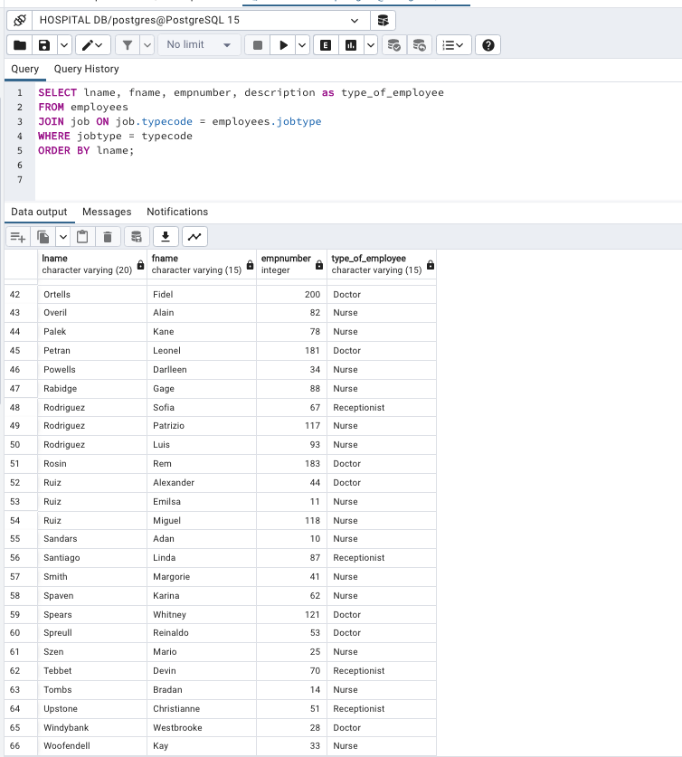

1. List the last name, name, employee number, type of employee of all employees ordered by last name grouped by employee type.

SELECT lname, fname, empnumber, description as type_of_employee

FROM employees

JOIN job ON job.typecode = employees.jobtype

WHERE jobtype = typecode

GROUP BY description,lname, fname, empnumber

ORDER BY description, lname;

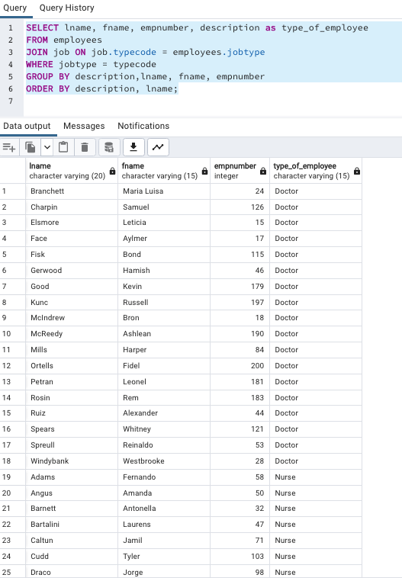

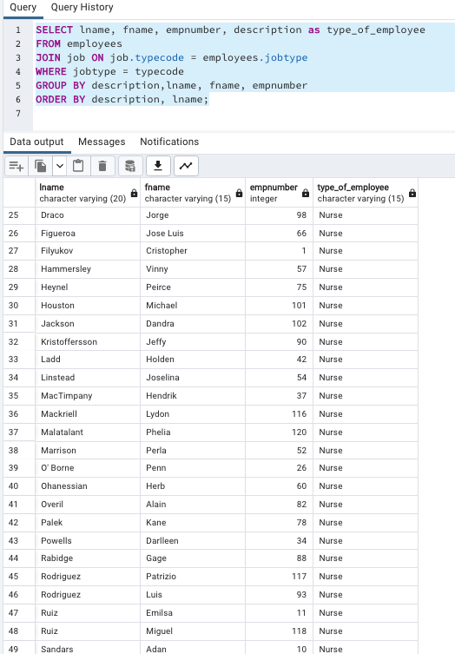

1. List the name, last name, employee number, Specialty of doctors. Group by specialty and order by last name.

SELECT fname,lname, employees.empnumber, description as speciality

FROM employees

JOIN doctor ON doctor.empnumber = employees.empnumber

JOIN spec_doctor ON spec_doctor.specid = doctor.specid

WHERE spec_doctor.specid = doctor.specid AND employees.empnumber = doctor.empnumber

GROUP BY description,lname,employees.empnumber,fname

ORDER BY description,lname

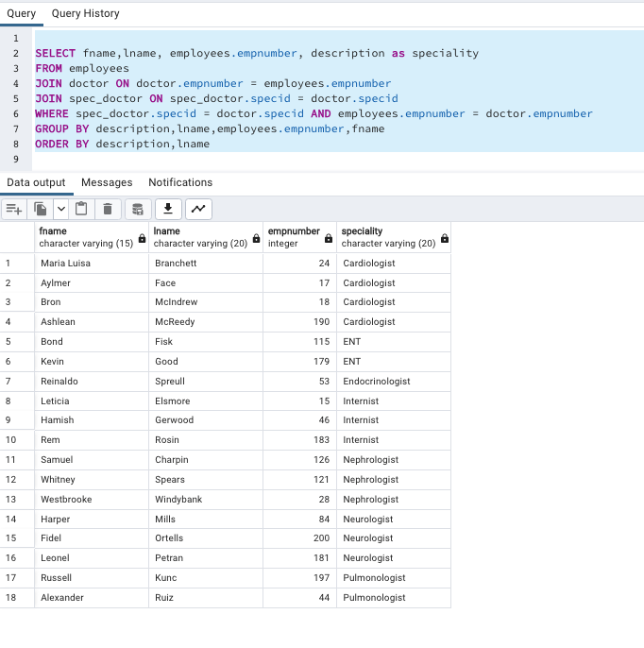

1. List the count of doctors per specialty order the list by specialty name.

SELECT description as specialty, COUNT(*)

FROM employees

JOIN doctor ON doctor.empnumber = employees.empnumber

JOIN spec_doctor ON spec_doctor.specid = doctor.specid

WHERE spec_doctor.specid = doctor.specid AND employees.empnumber = doctor.empnumber

GROUP BY description

ORDER BY description;

1. List the employees name, last name, employee type, salary with salaries greater than 85K.

SELECT fname,lname,description as employee_type,salary

FROM employees

JOIN job ON job.typecode = employees.jobtype

WHERE jobtype = typecode AND salary > 85000

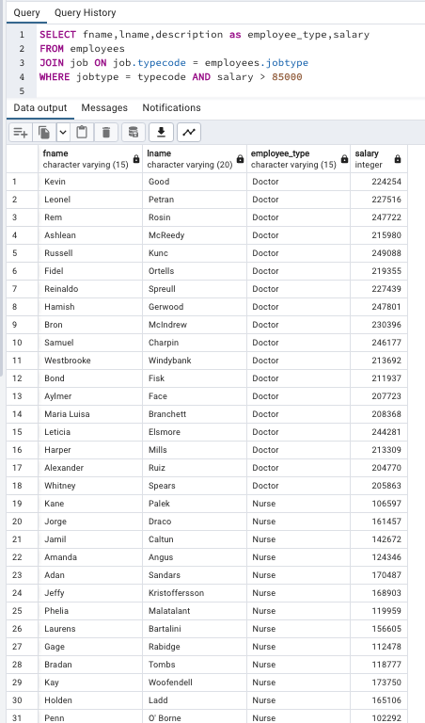

1. List the name, last name, sex, patient id and room number of all the patients not discharged yet

and who are older than 65 years old.

SELECT fname,lname,gender,patientid,proom

FROM patient

WHERE age > 65 AND datedischarg IS NULL;

1. List the name and last name and room number of patients admitted through the ER and already

discharged

SELECT fname,lname,gender,proom

FROM patient

WHERE erentrance = TRUE AND datedischarg IS NOT NULL;

1. List the specialty and number of doctors for the specialty that has more than 3 doctors that

make more than 100K a year.

SELECT description as specialty, COUNT(*)

FROM doctor

JOIN spec_doctor ON spec_doctor.specid = doctor.specid

JOIN employees ON employees.empnumber = doctor.empnumber

WHERE salary > 100000

GROUP BY specialty

HAVING COUNT(*) > 3

1. List the room number of any empty room.

SELECT **number** FROM room

WHERE **number** IN( SELECT **number** FROM room

except(SELECT proom

FROM patient))

1. List the average cost of a treatment.

SELECT ilness_type, AVG(medprice)

FROM contains

JOIN medicine ON medicine.medid = contains.code

group by ilness_type

